2006-11-21 [1101] Ta2O5 Wafer 3 11212006 Index Map

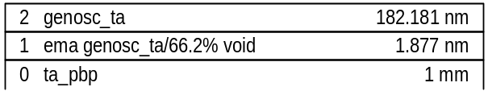

MSE=22.91
thick.2 182.181±0.199
thick.1 1.877±0.125
ema2.1 66.163±2.56
br1.2 0.60329±0.0112
en1.2 4.8739±0.0115
amp1.2 2.5796±0.0537
polemag.2 113.25±0.735
e1offset.2 1.6154±0.0105

